所有优秀的范例文章都可以通过国际人才交流平台(http://international-talent.cas.cn)的Story栏目进行全文发布，同时会在Linkedin的PIFI（https://www.linkedin.com/company/13746116/）进行推送。

范例1

Successful story at CAS

Essay Title | Returning to the IVPP: a productive homecoming
Name | Last name | ***
 | First name | ***
Citizenship | ***
Passport number | ***
CAS Institute | ***
Chinese cooperator | ***
Project Number | ***
PIFI Category | ***
signature | ***

Contents | My initial response to having received a prestigious CAS PIFI award was pleasure and satisfaction. My contact with the IVPP goes back to 1980 when I spent a brief post-doctoral period in China, establishing scientific contacts that, as it turns out, would form the basis of my entire professional career. Over the years, I have visited the IVPP many, many times, including multi-month research stays on several occasions. My experience as a PIFI Visiting Scientist has reinforced and expanded all of these previous and current contacts, and for that, I am profoundly grateful!  I had a thoroughly enjoyable and productive three-month visit at CAS. My accommodations at the Xiyuan Hotel were first-class and very comfortable for a long-term stay. Situated directly across the street from the IVPP, the Xiyuan has become my second home!  CAS’s Institute of Vertebrate Paleontology and Paleoanthropology (IVPP) is one of the world’s foremost research bodies in the fields of vertebrate paleontology, Paleolithic archaeology, and human evolution.  My hosts, Drs. Gao Xing and Li Feng, spared no effort to ensure that my three-month stay in Beijing was both productive and comfortable and I am pleased to report that during my visit I engaged in the following principal activities:  - Jointly published (as junior co-author) an article in Science describing collaborative archaeological research in Tibet and reporting evidence of Tibet’s earliest known human inhabitants, some 40-30,000 years ago.  - Jointly published (again, as junior author) an article in the Journal of Quaternary Science presenting the results of a course of Paleolithic research undertaken in Shandong to understand the relationship between Ice Age human populations and changing ocean shorelines.  - Completed two additional article-length archaeology manuscripts wth IVPP co-authors; one accepted for publication (27 March 2019) by Quaternary International and one submitted and under review by the Proceedings of the National Academy of Sciences.  - Participated as the only invited international speaker at the 2018 Annual Hebei Province Field Archaeology Report Meeting in Shijiazhuang in January.  - Presented a weekly two-hour seminar on “Theory in Archaeology” attended by undergraduates from several Beijing universities and by post-graduate students affiliated with CAS.  - Hosted and led occasional afternoon discussions with students (over pizza!) on topics ranging from anthropological definitions of the concept of Culture to applying for graduate school and postdoctoral positions at North American universities.  - Engaged in substantial editorial work for the IVPP, leading to an invitation from China’s premier paleoanthropologist, Academician Wu Xinzhi, to become a Deputy Editor-in-Chief of the Institute’s flagship journal, Acta Anthropologica Sinica. I have humbly and happily accepted that invitation.  - Took part in planning future archaeological expeditions in Inner Mongolia, some in collaboration with counterpart institutions of the Russian and Mongolian Academies of Sciences.  As you can see, my list of of activities accomplished is both varied and abundant!  In future, I look forward to furthering and expanding my research ties with CAS through the IVPP. My PIFI visit has set the stage for multiple lines of collaborative research and I especially look forward to hosting Chinese colleagues at my home institution, the University of Arizona, as our joint work continues to develop.  In 1990-1991 I was the Resident Representative in Beijing of the U.S. National Academy of Sciences, during which period I interacted frequently with my CAS counterparts. Now, a quarter-century later, I am pleased to see CAS’s unwavering commitment to the development of China’s global research profile has continued unabated, in part through continued well-supported collaborations with the international scholarly community.  The PIFI program is a clear indication of China’s rising stature in twenty-first century science. The generosity of this program will, I hope, be matched by the contributions of its participants and, in this regard, I hope my own small input will be well-regarded.  Finally, I want to thank the CAS for creating the PIFI program and affording me this most-welcome opportunity to further strengthen and expand my longstanding scholarly ties with the IVPP.

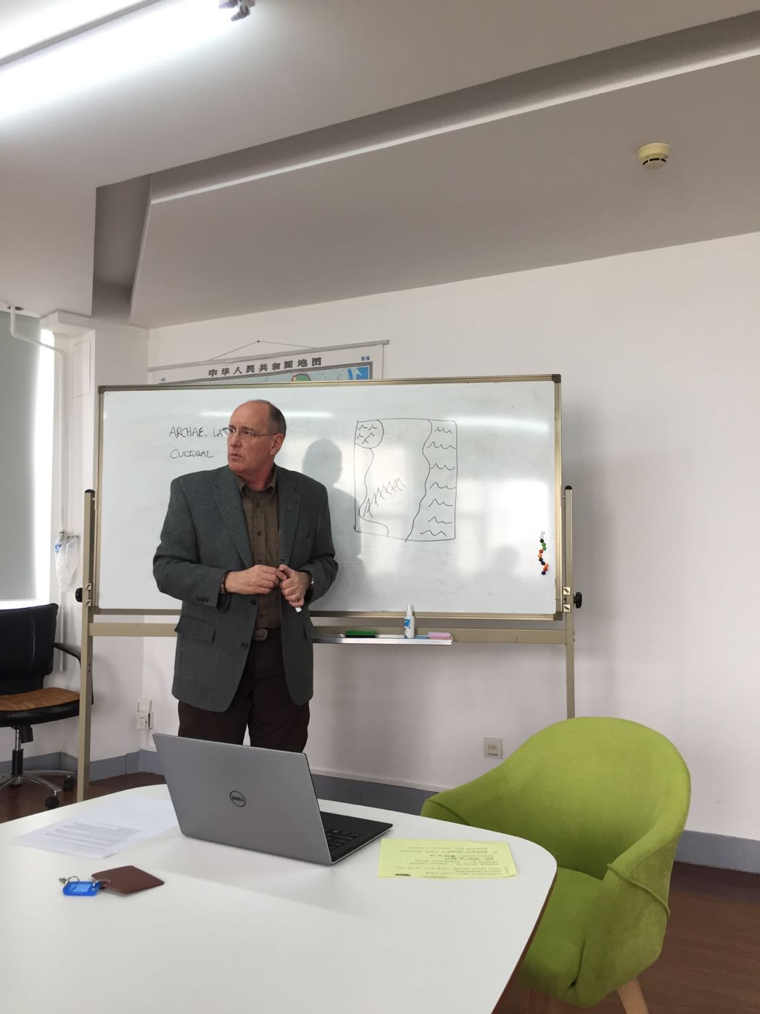

Olsen教授在中科院古脊椎所授课
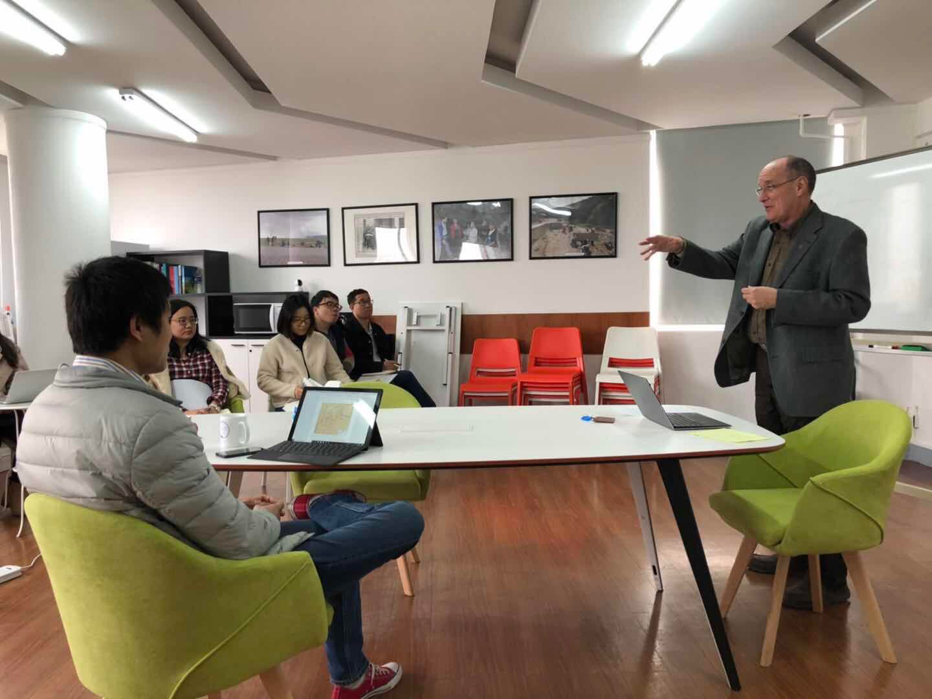

Olsen教授在中科院古脊椎所授课

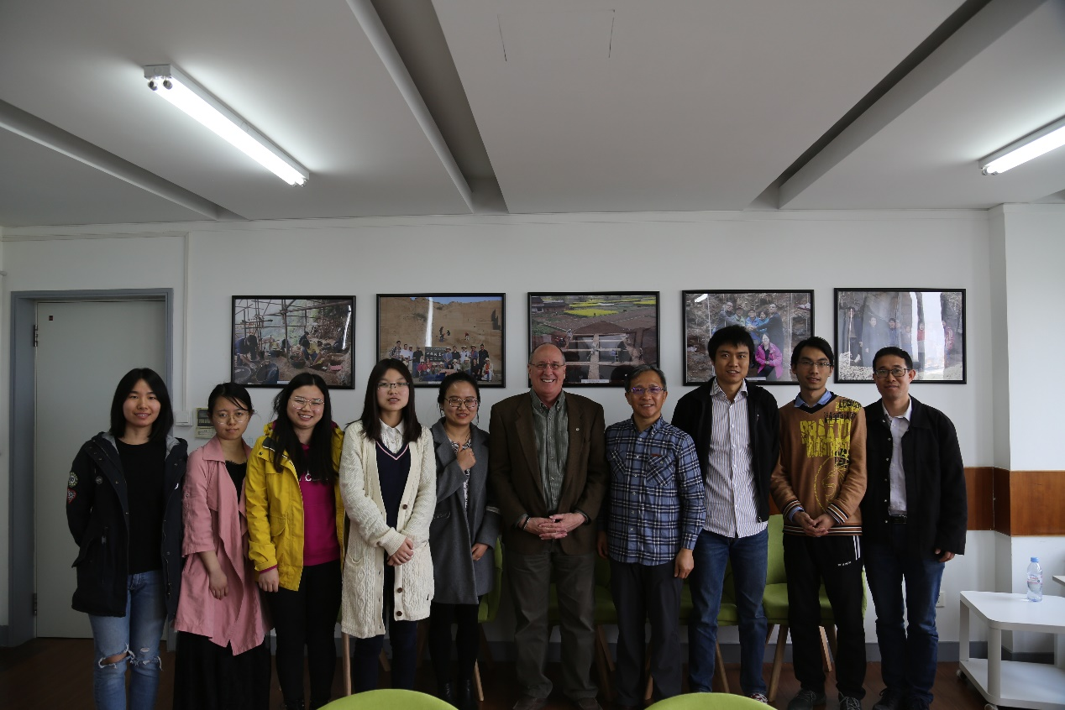

Olsen教授主讲考古学理论讨论课后主要学员合影

范例2

My Success Story at CAS

Essay Title | Science and culture through international collaborations
Name | Last name | ***
 | First name | ***
Citizenship | ***
Passport number | ***
CAS Institute | ***
Chinese cooperator | ***
Project Number | ***
PIFI Category | ***
signature | ***
Contents | Moving from the Netherlands to China was an exciting time. Although I have experience in traveling and living abroad, it is always exciting to move to a new place, a new culture and make new friends. Living in China is very different from living in the Netherlands, not only because of the size of the country but also because of the culture, which makes living in China so exciting. Walking the Great Wall and visiting the ancient cultural heritages like the Forbidden City and the Temple of Heaven is wonderful. But the hospitality of the people and the culture of always sharing a meal is something I cherish.  I am very happy I moved to China and that I am able to continue my stay with the PIFI scholarship. There are still so many different places to see, foods to eat, and characters to learn.  I contacted prof. Keping Ma for a post-doc position because of his outstanding science and his international collaboration. Therefore I had the privilege to land in an international-minded group that accepted me and helped me out in many different ways. I am so lucky that my colleagues became my friends and I can keep working with them for two more years. In addition to the international consortium in which I started working (BEF-China), different professors from all around the world come and visit the IBCAS. International collaboration is something I love in my job as scientist; people from different cultures and backgrounds make work interesting and this kind of diversity is good for creativity and development within science. Therefore, I am thankful to work together with prof. Ma and dr Liu; being part of a high standing international collaboration as the BEF-China is a privilege. Within BEF-China I work on the role of functional traits on tree growth, which is exciting in itself. And recent developments in statistical analyses to determine functional diversity within communities enable even more in depth understanding of forest ecology. In addition, I also get the chance to learn about plant-insect interactions and the role of soil-microbial communities, creating a whole-ecosystem perspective. But not only in the BEF-China consortium, but also from colleagues of the Biodiversity and Biosafety group of prof. Ma who work within other ecological projects, I learn and improve my skills within ecological research.  I believe that working at the IBCAS for the coming years will improve my scientific work but also my cultural awareness. While I will learn a lot from my Chinese colleagues about science and the Chinese culture, I also hope that I can teach them something. I am very happy to have received this CAS-PIFI scholarship to continue working within BEF-China and contribute to the field of biodiversity-ecosystem functioning. The CAS-PIFI scholarship is a great step in my career as young-scientist, and I hope that in the future, wherever I will go, collaborations with CAS are possible.

